**ASSESSMENT**

Create a Django project to fulfill the following requirements.You can use any of the frontend framework to visualize the table structure with your own mechanism.

1. Please find the sample dataset **Interview_dataset.zip** in the link.
2. Read the CSV files and create the following tables accordingly.

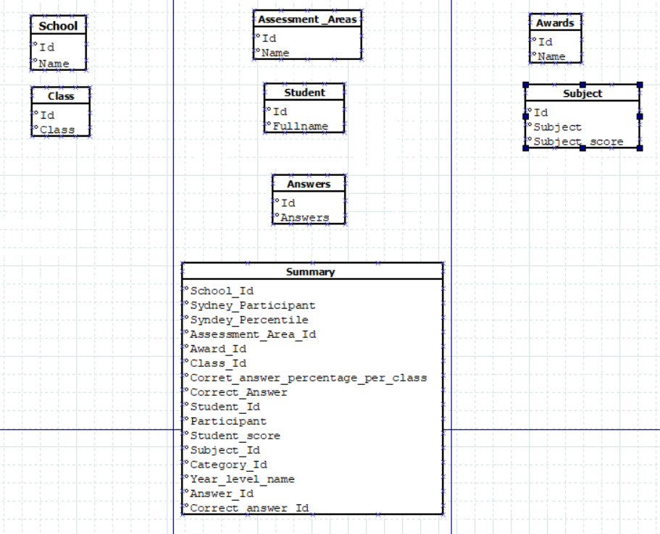

1. Visualize the table structure, no need to create or visualize any of the relationships.
2. Visualize all the data points for the mentioned tables at the same time.
3. Dockerize the solution.
4. Create a README.md file with the instructions to start the project.